

**Wild Animal Silhouettes**

A silhouette is an image of something that is represented as a solid shape or single colour so that we only see the outline. Create some wild animal silhouettes! Think about:

* Which animals will you draw?
* Are the silhouettes of some animals easier to create than others? Why? E.g. those with distinct features such as a trunk may be more recognisable.
* What size will your silhouettes be? If they are too small, will they be tricky to cut out or recognise?

Draw your silhouettes or use the examples below.

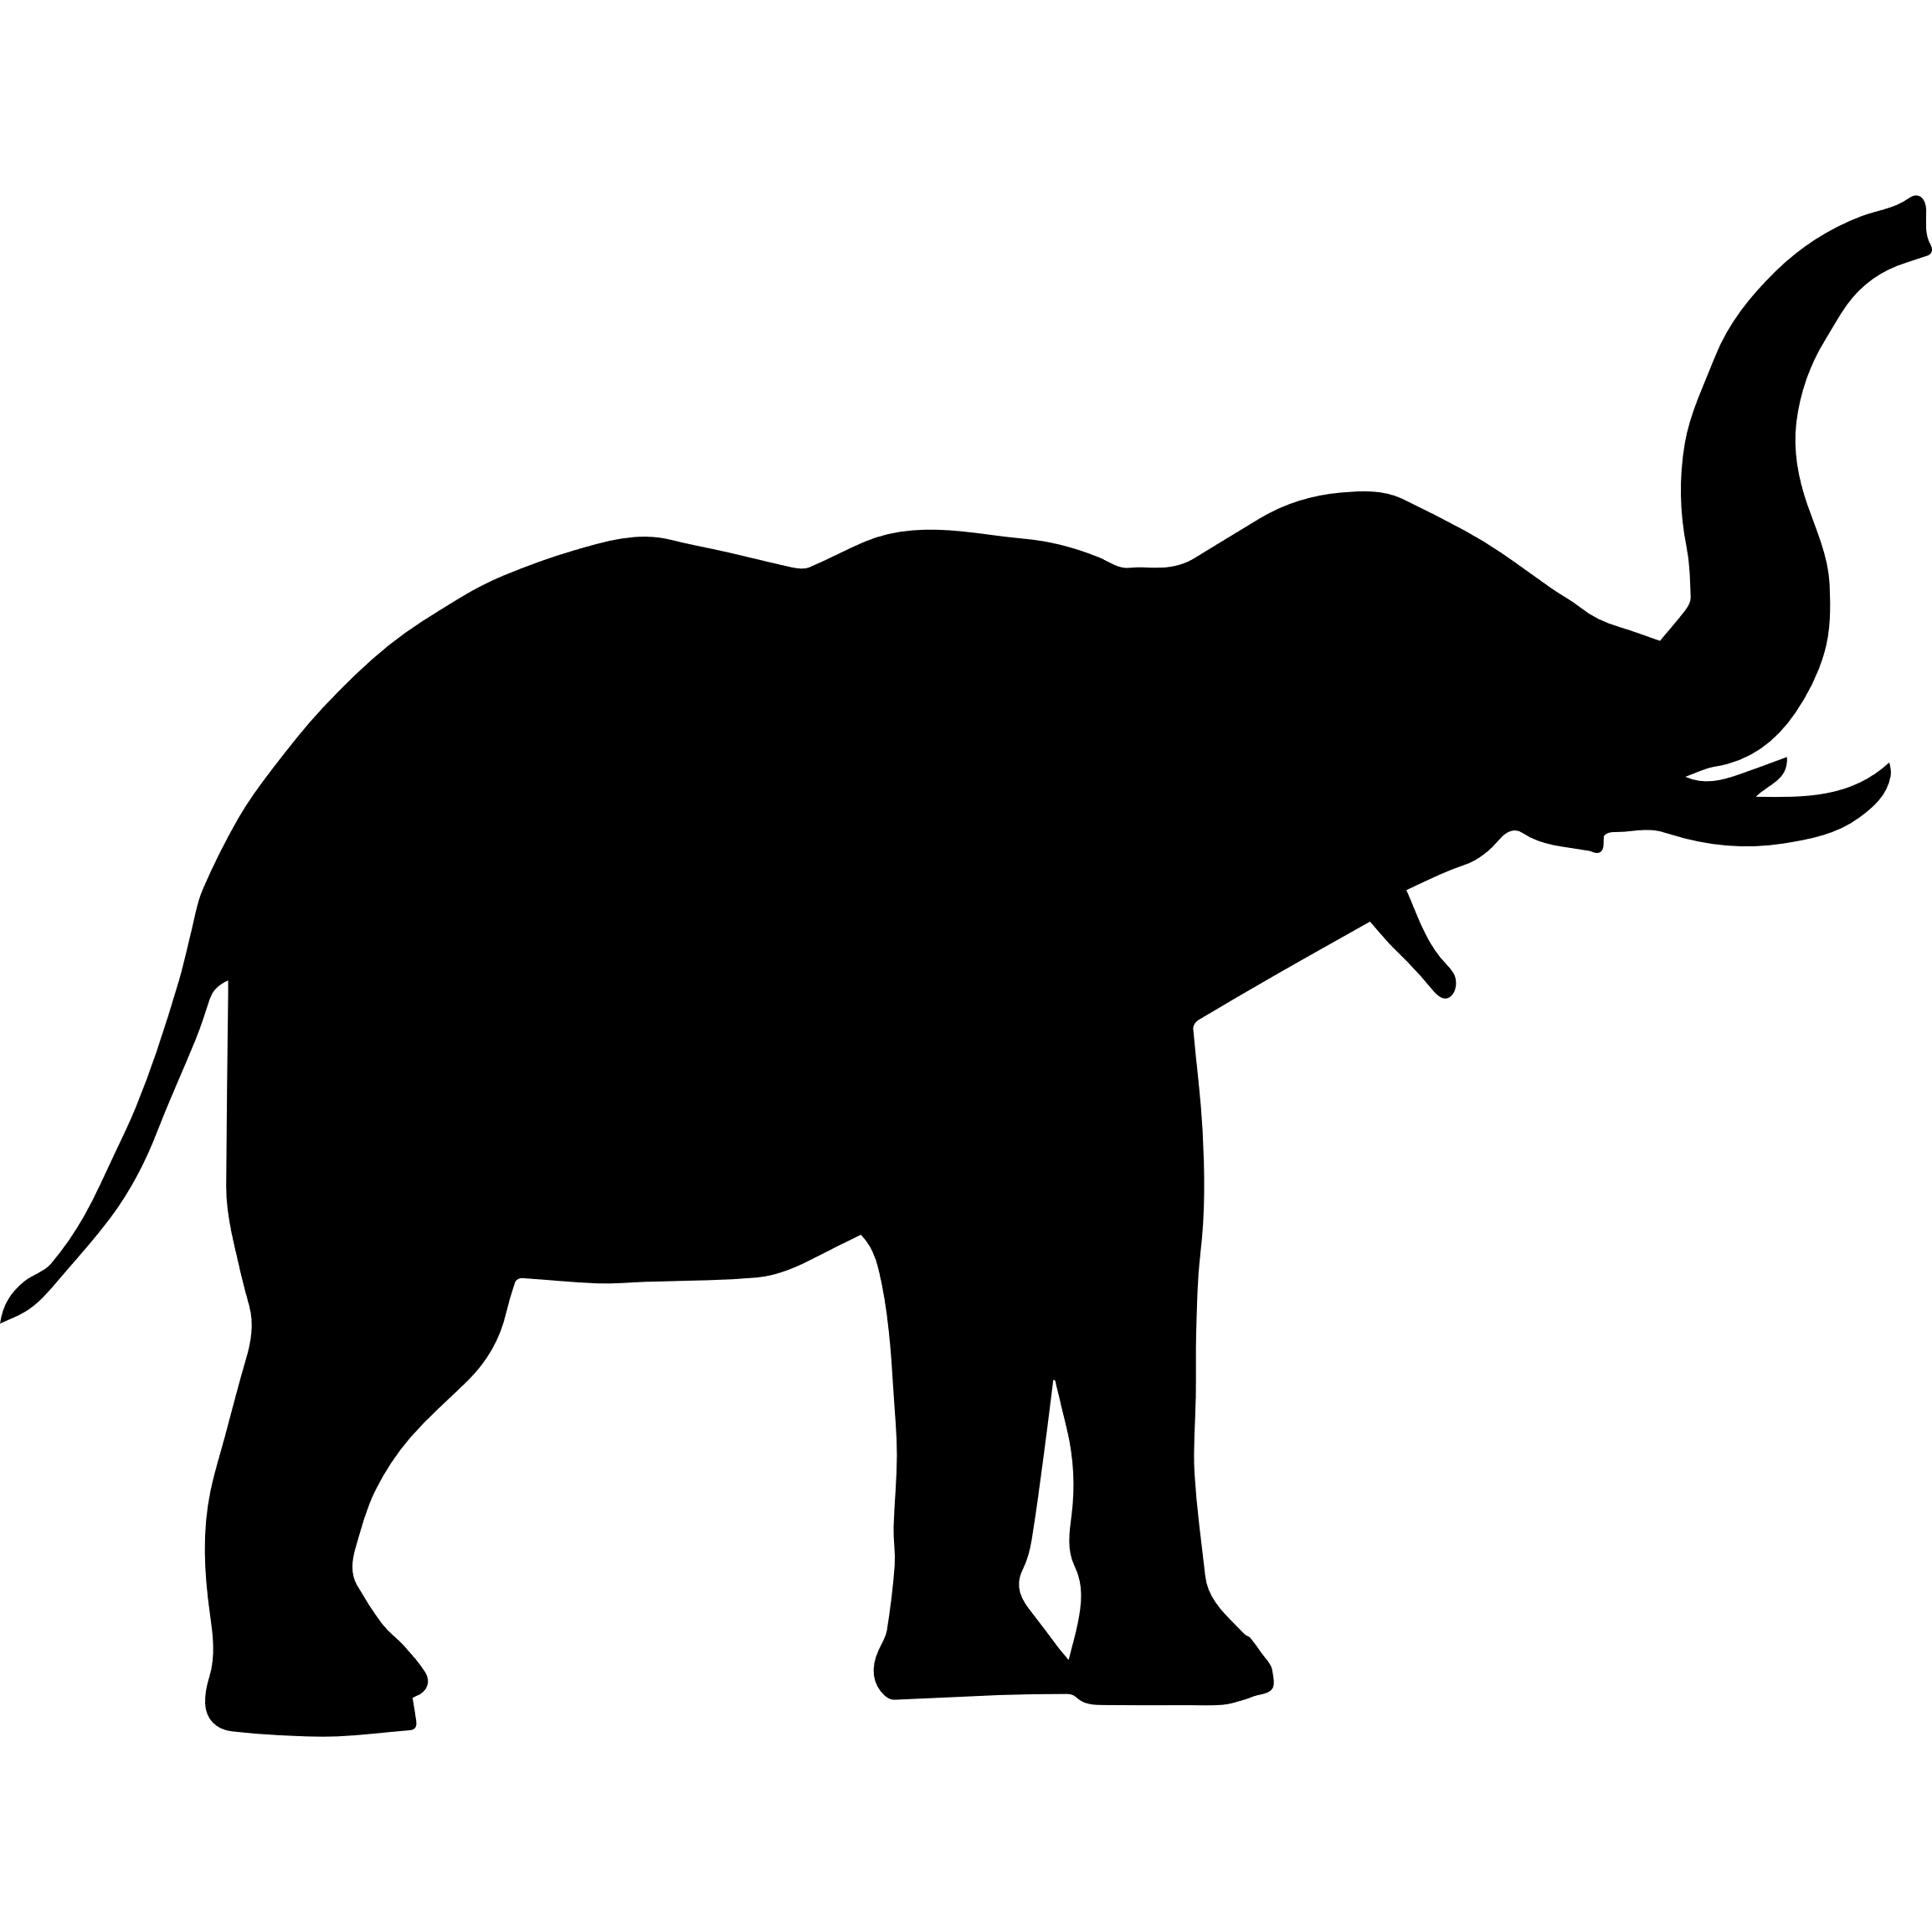

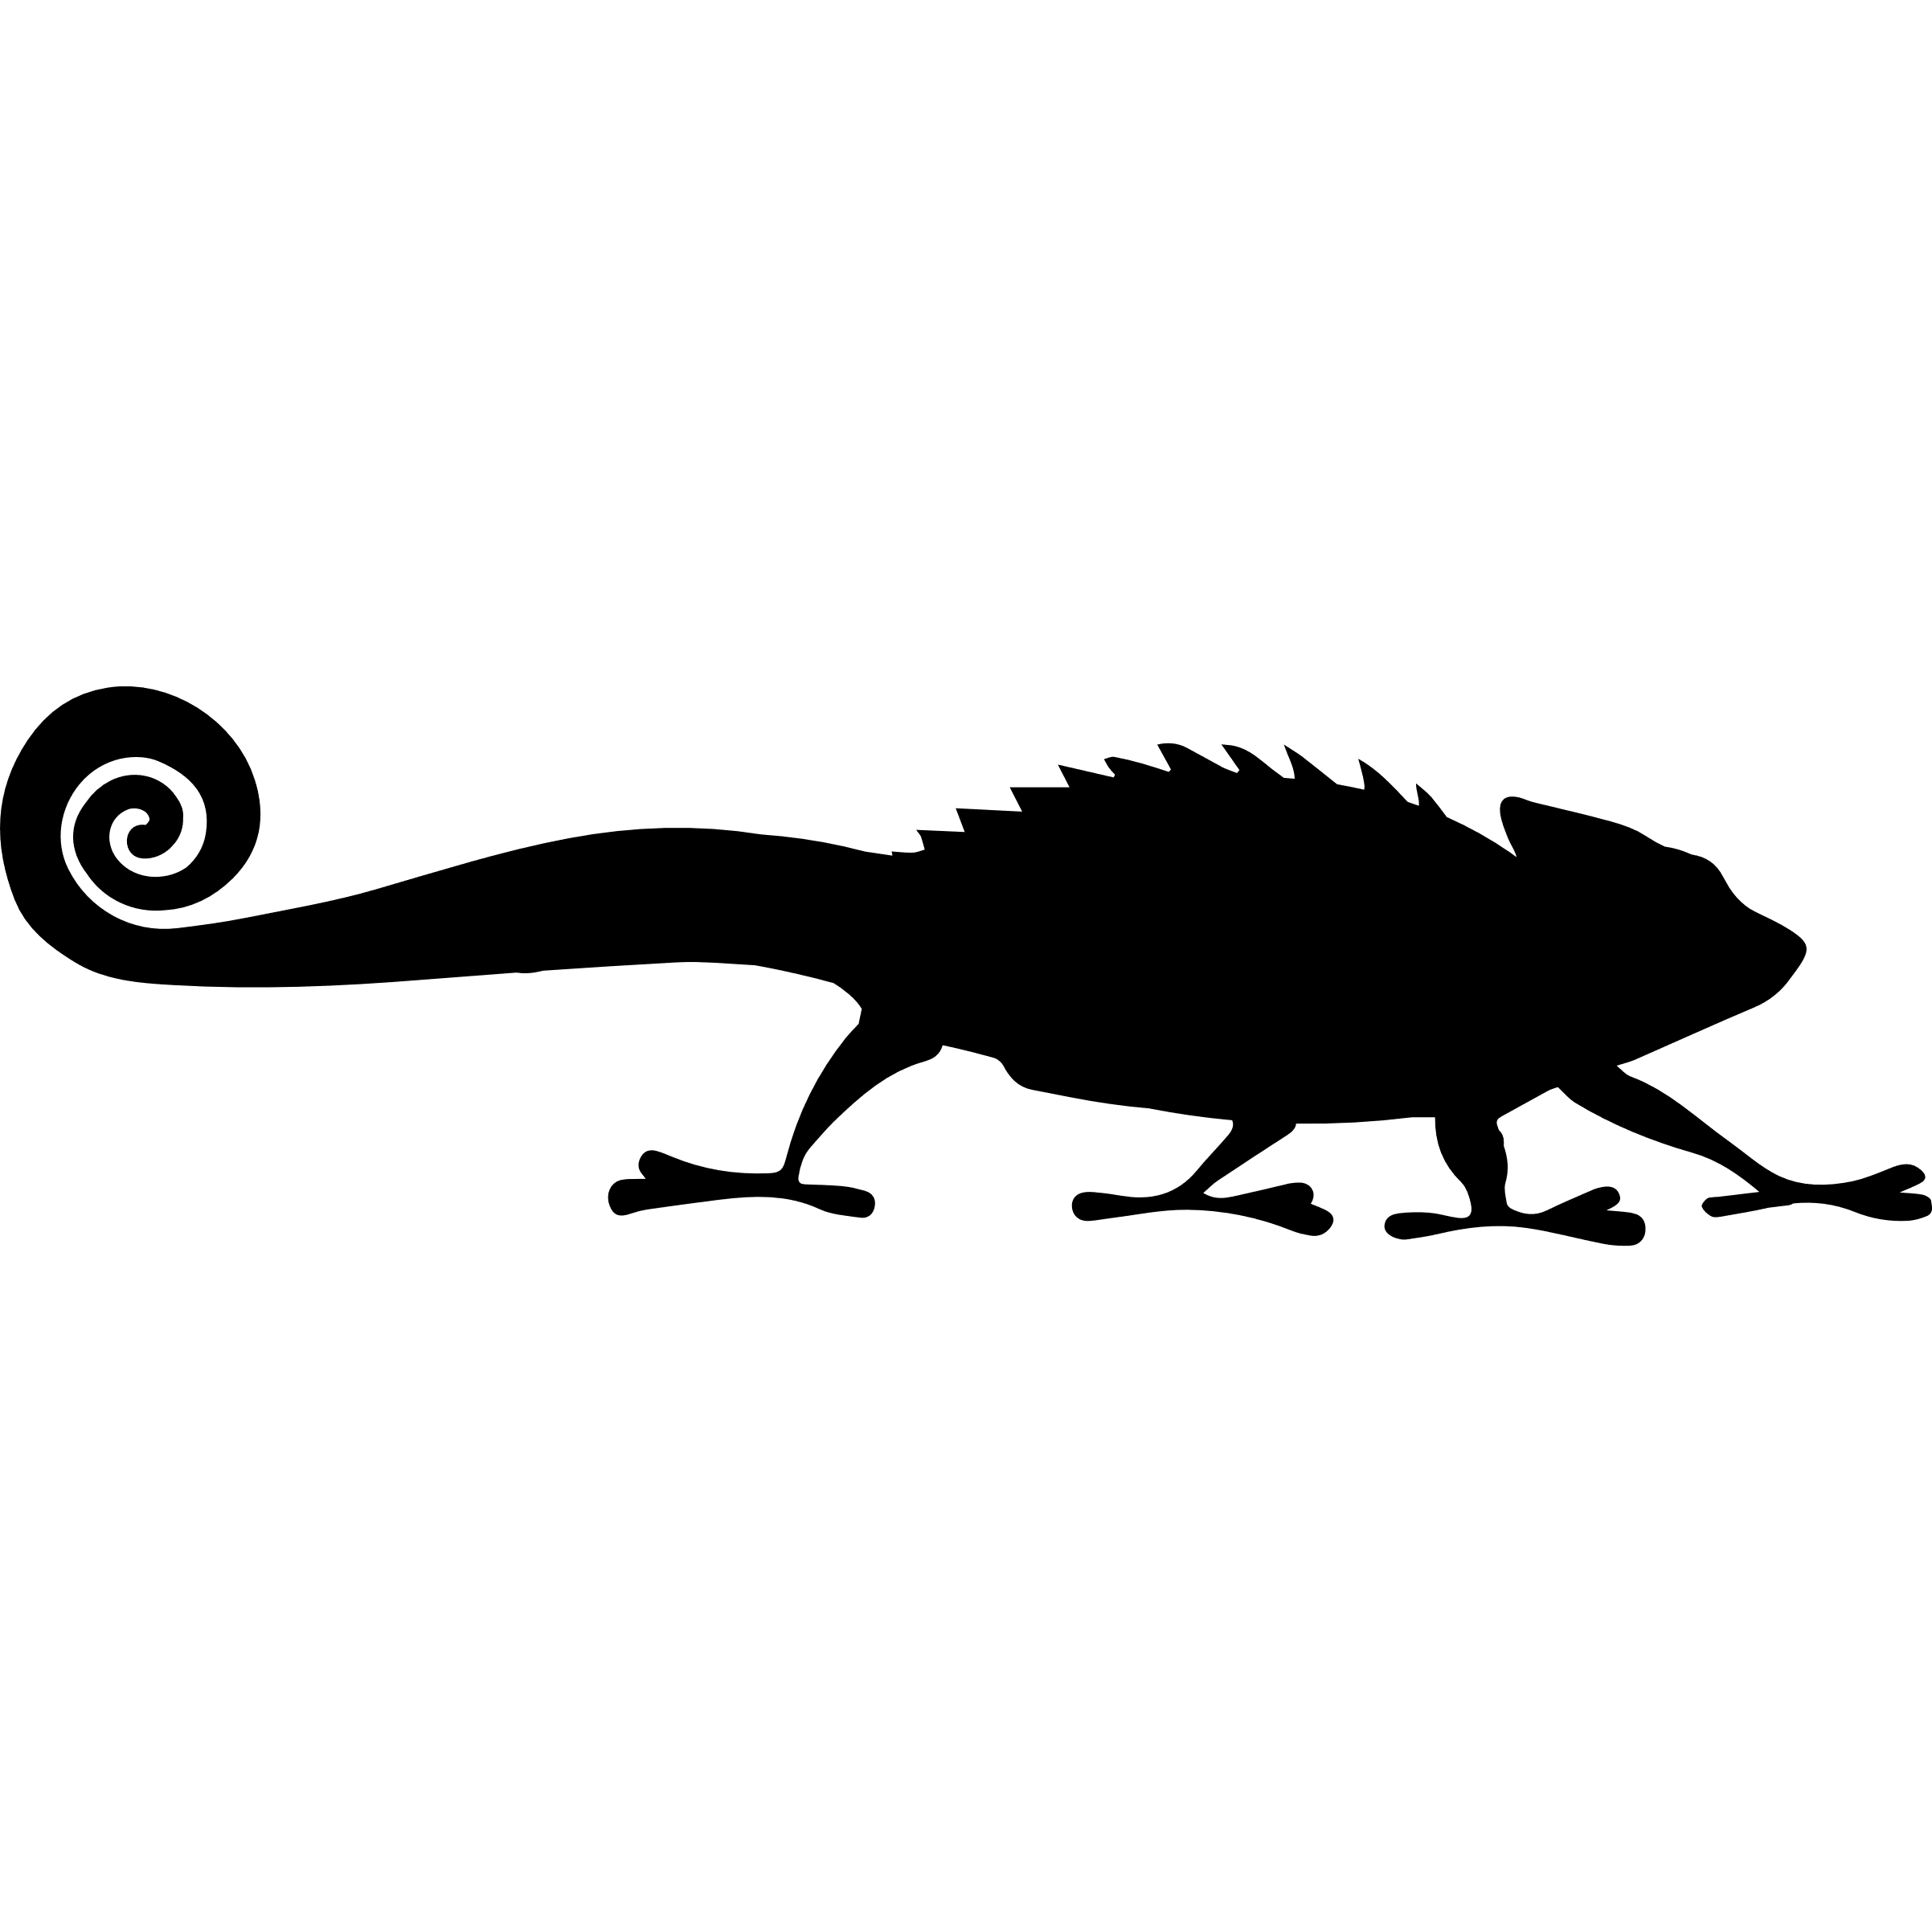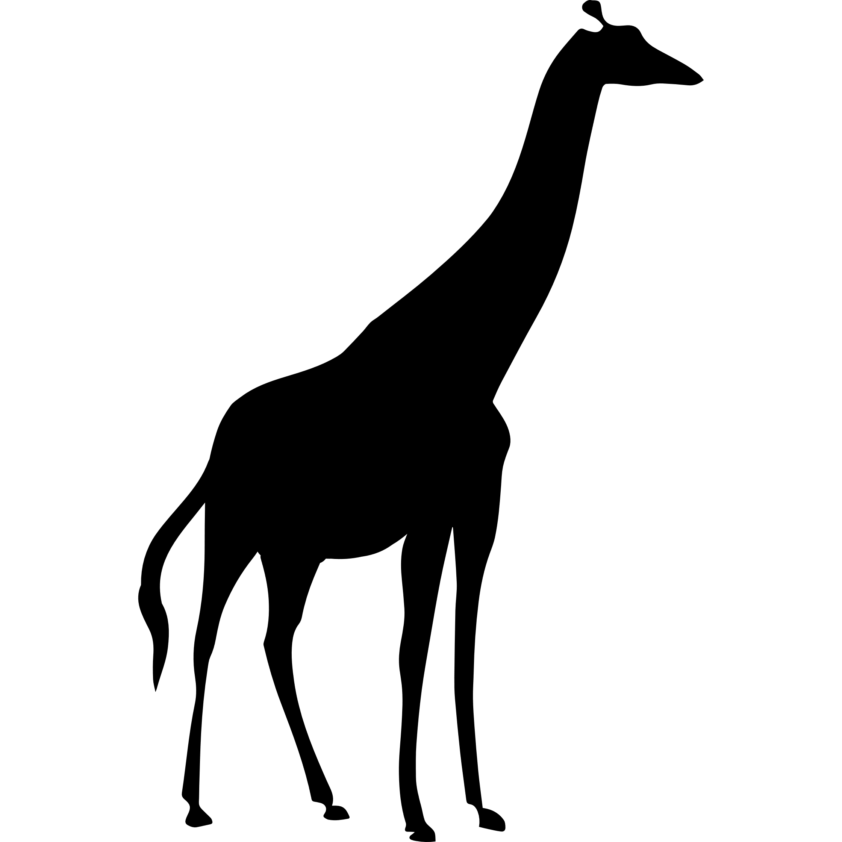

**Use your silhouettes to create a picture or make a shadow show, using a torch and a dark room.**