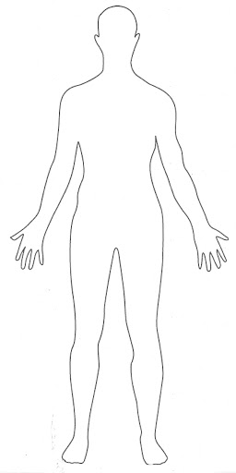
Activity 1 – warm up

What body parts do you know?
Write or draw them on.
Activity 2
The four human teeth
Name_________________________________

Features __________________________________________________________________________________

Function ___________________________________________________________________________________________________________________________

Name_________________________________

Features __________________________________________________________________________________

Function ___________________________________________________________________________________________________________________________
Name_________________________________

Features __________________________________________________________________________________

Function ___________________________________________________________________________________________________________________________

Name_________________________________

Features __________________________________________________________________________________

Function ___________________________________________________________________________________________________________________________
Activity 3
Model of teeth

Try making a model of your teeth, possibly using resources like these…

Clay model
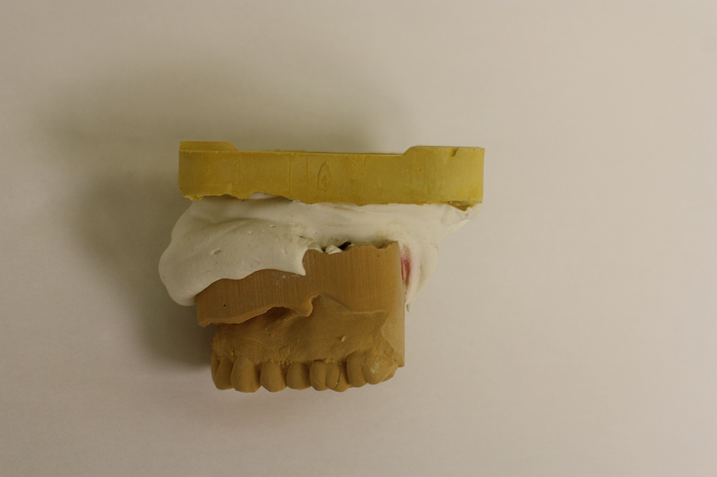

Modeling clay or play dough
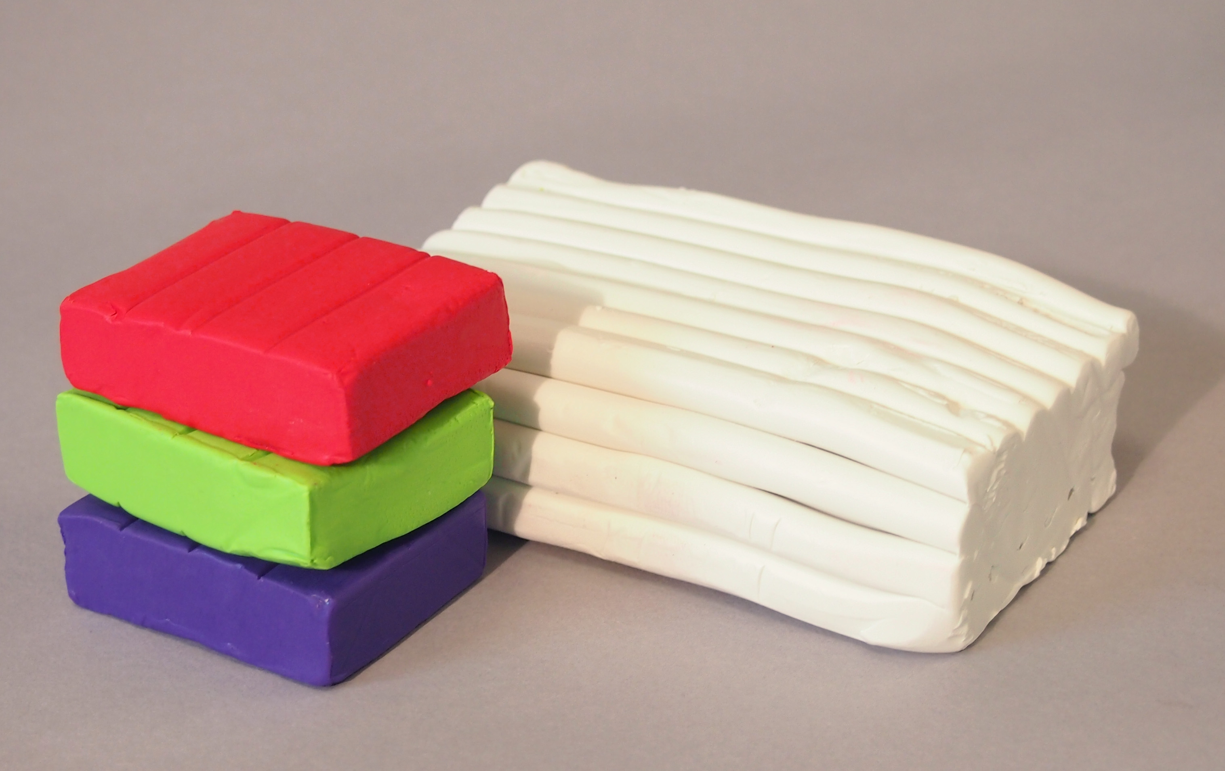

Junk model
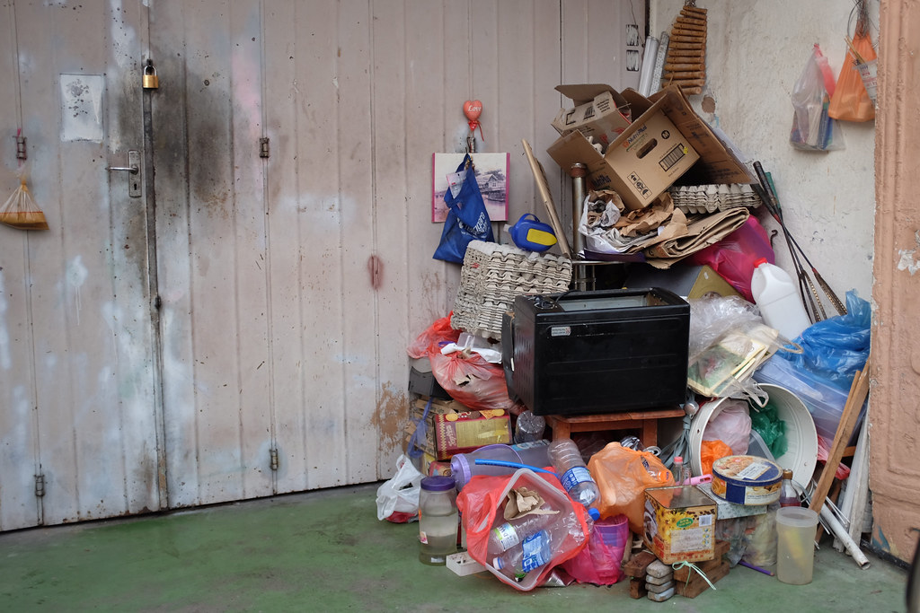
Activity 4
Healthy teeth poster
Create a poster encouraging people to brush their teeth regularly, especially after eating. and explain how they should do it and why.

Here are some examples…

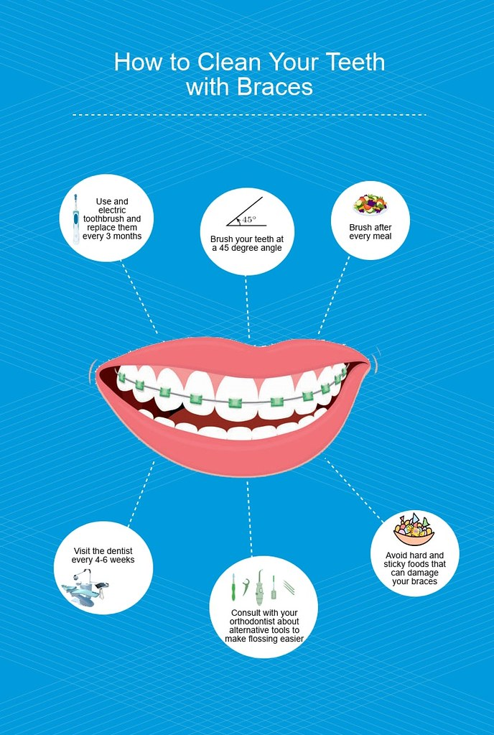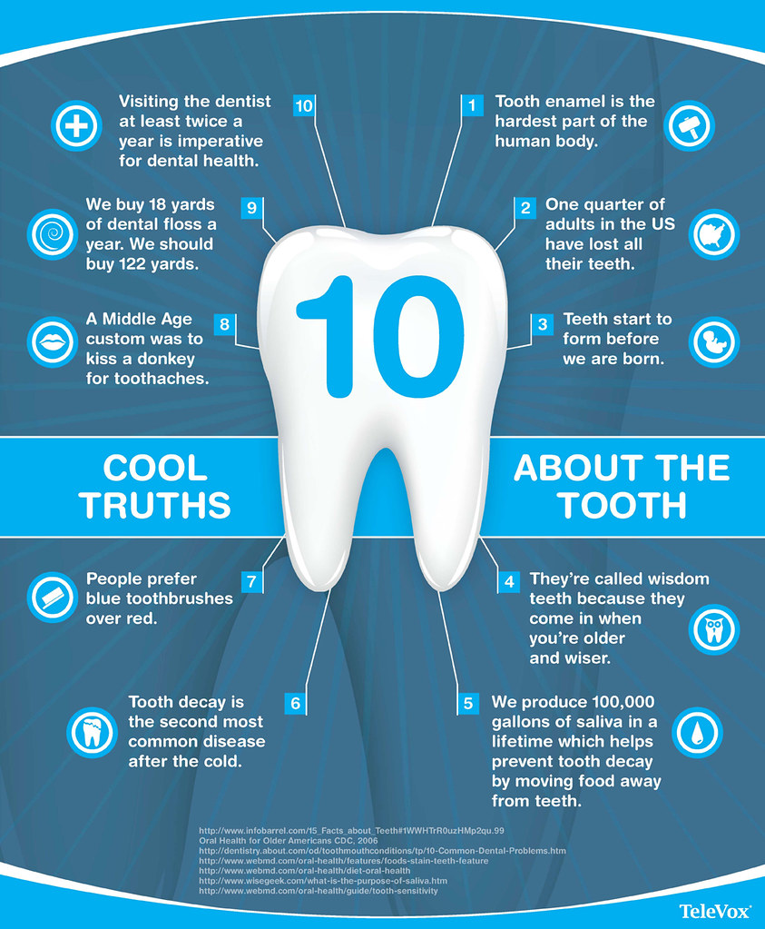

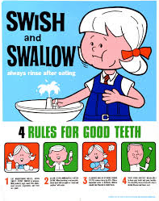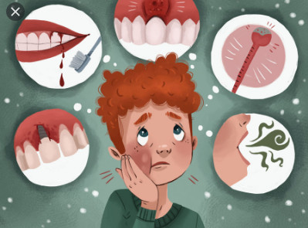

Activity 5
Please talk to an adult before doing this, as you need to use uncooked eggshell.
Enquiry – Eggshells

Question ___________________________________________________

Prediction _________________________________________________
______________________________________________________________

Resources: Eggshells (raw), 5 different drinks, cups

Method
- Pour the same amount of fizzy drink, vinegar, water and tea or coffee into your jars.
- Place a piece of egg shell in each jar
- Leave for a number of days
- Remove the egg shell
- Record the change
Results
Drink | Observation 1 | Observation 2 | Observation 3
Was my experiment fair?

_______________________________________________________________________________________________________________________________________________________________________________________________________________

Conclusion

How will you show your results?
What advice could you give people?
Was your prediction correct?

A little bit of extra fun…

EGG IN VINEGAR EXPERIMENT
This rubber egg experiment is a classic science activity! Make a naked egg or bouncy egg. Can it bounce? What happens to the shell? Does light pass through it?

RUBBER EGG EXPERIMENT

YOU WILL NEED:
- Raw Eggs
- Household Vinegar
- Jar/Vase

STEP 1: Place an egg in the jar and cover with vinegar. You can colour the vinegar for rainbow coloured rubber eggs too!

STEP 2: 24 hours later, drain and refill with vinegar. Set aside and patiently wait 7 days. Yes! One whole week until your naked egg is ready.
Notice the bubbles on the eggshell! This is the acid in the vinegar reacting with the calcium carbonate in the shell. This reaction is producing a gas called carboin dioxide!

STEP 3: After 7 days, remove the egg and rinse it off. Ours had a layer of brown scum that was easily washed away! The hard outer shell is gone and the egg white and yolk are surrounded by a thin membrane.

Alternatively, you can try out the eggs in vinegar after 48 hours!

Activity 6
Match the skull with the animal
Look at the teeth for clues
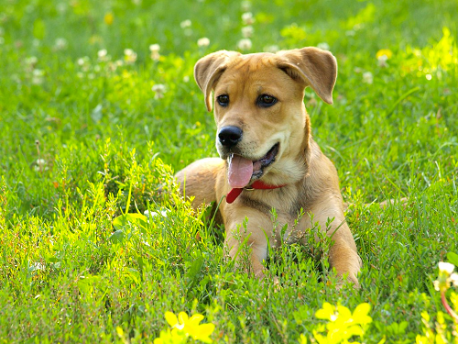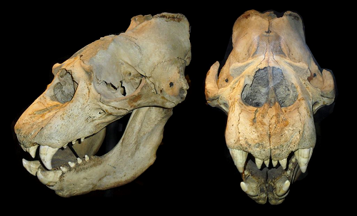
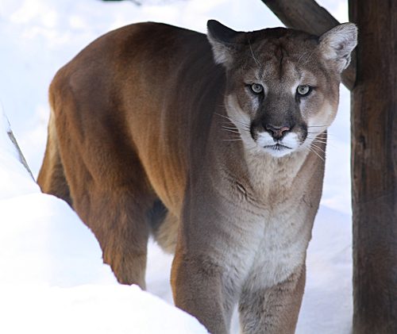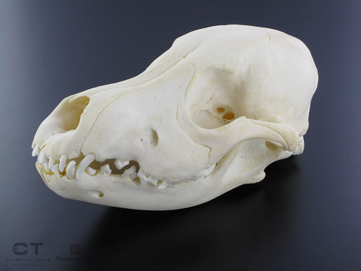
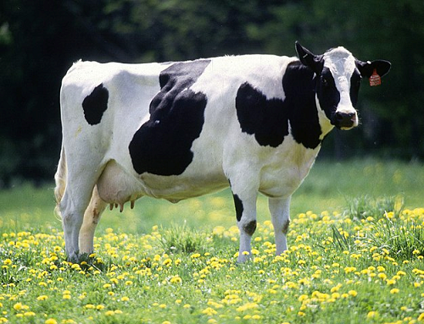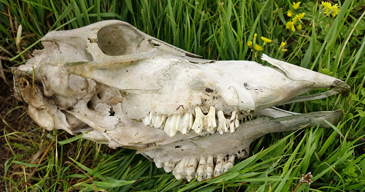
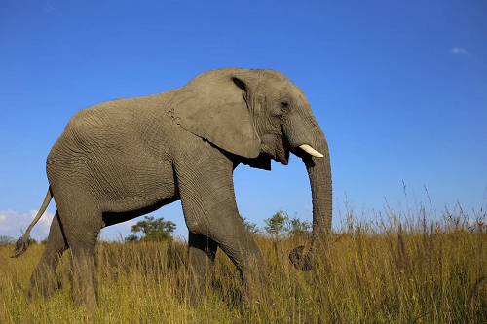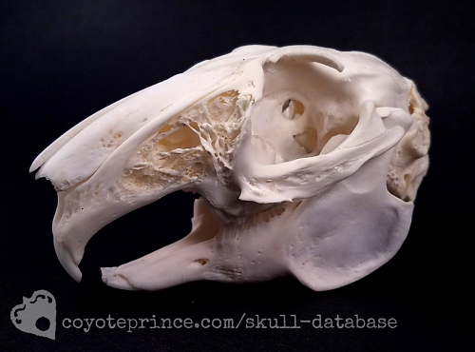
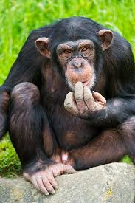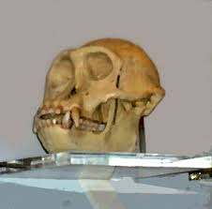
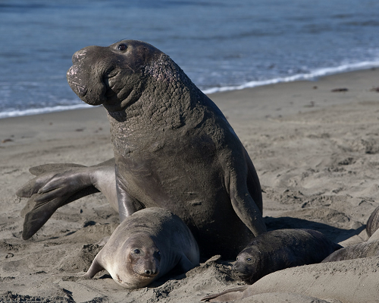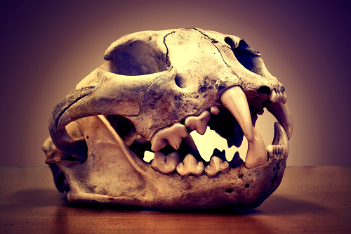
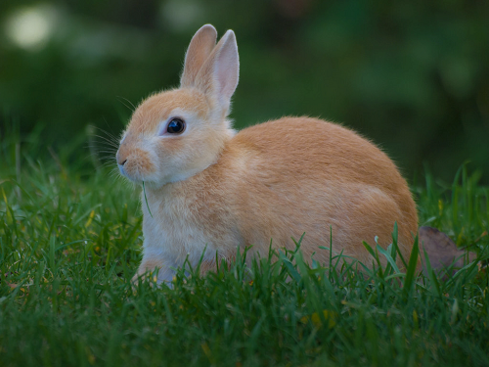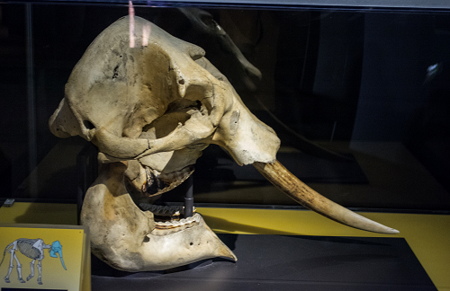

Can you create your own game?

