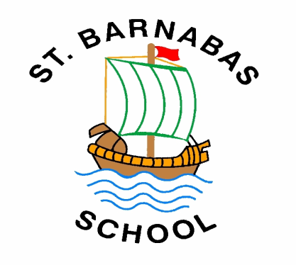
Before we introduce you to the ‘Support for Your Child at St Barnabas C of E Primary School’ booklet we would like to explain a few acronyms that you may see in this document. Believe us when we say that we understand they can be confusing but we will try to define them as much as possible.
SEND – Special Educational Needs and Disability
SENCo – Special Educational Needs Coordinator, the designated teacher who oversees provision for children with SEND.

“Barnabas, the Encourager”

Support for Your Child at St Barnabas C of E Primary School
St Barnabas CE Primary School endeavours to provide a supportive, caring and nurturing environment where every child matters. All children are valued equally and are given opportunities to achieve the very best that they can. However, some children may need additional support to help them achieve this. This may be for a short period of time to help with a specific learning need or for the time they are in the care of our school.

In this booklet you will find the types of support that are available for your child at St Barnabas CE Primary School. It will help you understand who can help if your child needs additional support and how this support can be accessed.

At St Barnabas we offer a wide and varied curriculum and children receive quality first teaching from experienced teaching staff. Teachers plan lessons using a range of teaching styles and approaches. Lessons are differentiated to meet children’s learning needs. In class, children have access to a range of support from small group work to one-to-one support from a teacher or teaching assistant. We also promote independent learning within class as this forms a key skill for later life.

Who is responsible for providing for my child’s needs?
Class teachers are trained to assess, plan and teach according to your child’s learning needs so they are the first person to see if you have any worries, concerns or questions.
Miss Connolly is our school SENCo and will oversee provision for any child with SEND. She will liaise with class teachers, teaching assistants and outside professionals to make sure that your child’s needs are being met. If you need to contact her, please email stbarnabas@york.gov.uk or call the school office on 01904 653323. She is always happy to talk to you about any worries or concerns.
Miss Boardman - as well as being head teacher, Miss Boardman is head of inclusion at school and is also available if you have any questions or concerns.
Anne Williamson – Anne Williamson is now Link Governor with a special interest in children with additional needs. She previously worked as a Senior Paediatric Physiotherapist, at York Hospital, working with children with physical and learning disabilities in special and mainstream schools. With this background, Anne hopes to bring a different perspective, working in collaboration with Eileen Connolly, SENCo, to positively enhance the provision for pupils with additional needs.
Mrs Blows – Children’s Champion who oversees children’s social and emotional needs.
I am happy with the progress that my child has made. He has received extra support and teaching which has really helped…a personal touch.
Mrs T. Year 4 parent

How do we identify Special Educational Needs and Disabilities (SEND)?
Teachers at St Barnabas continually assess and check the progress of children in their class. If teachers do not think that your child is making the same progress as other children or is falling significantly behind age related expectations, he/she may be considered to have a Special Educational Need. Our SENCo will then help support you and your child’s class teacher to address your child’s learning needs.
We will talk to your child to find out what they find difficult, we will observe them in class and then assess their learning needs. It may be necessary to use a reading or maths test to further assess what they are finding difficult and will then tailor support to address these needs. This may be by means of extra support in class or a programme of intervention. They may then be placed on the SEN register and you will be informed of this.
If your child has been identified with SEND before they start here at St Barnabas, we will work with those who already know about them and use the information that is available to identify how school can continue to support their needs.

How do we involve pupils and their parents and carers?
Parents are the experts when it comes to their children and know them better than anyone. It is crucial therefore, that we continue to develop the relationship between parents/carers and school to help children to reach their full potential. Parents can expect to be informed of assessment outcomes and regularly invited in to school to review progress and be involved in the target setting process.
Children may receive an Individual Learning Plan (ILP) with small measurable targets to help monitor progress and attainment. A copy of this will be sent home. If we feel that a child may need more support in the future or we feel that other agencies, for example an Educational Psychologist, may need to be involved we may set up a My Support Plan (MSP). This will allow us to closely monitor progress and is a way of passing information to other agencies if needed.
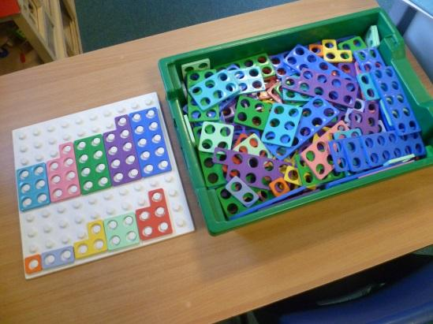
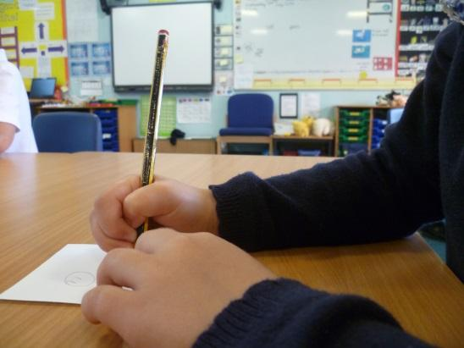

Categories of Special Educational Needs:
The SEND Code of Practice outlines four broad areas of Special Educational Need. We have tried to outline below a brief overview of these broad areas and the types of learning needs that may fall into each area.
Communication and Interaction:
- Difficulties understanding others
- Difficulties expressing themselves
- Difficulties with speech.
Children may be referred to a Speech and Language therapist if we feel that they have a specific speech and language need, if this problem has not yet been picked up in pre-school provision. Examples of intervention that may be used by school for children with communication needs may include ‘Talk Boost’ or ‘Time to Talk’.
Children who may have an Autistic Spectrum Disorder (ASD) including Asperger’s Syndrome and Autism would be classified in this area of need.

Cognition and Learning:
- They may need support with school work
- May not be making expected progress in reading, writing and maths
- May have difficulties understanding information
- May have poor concentration and attention skills
Children who are on the Dyslexia Continuum would be classified in this area of need.
Social, Emotional and Mental Health Difficulties (SEMHD):
- Behaviour difficulties that may get in the way of an individual learning.
Please do not be alarmed by this area of need. We understand that ‘mental health’ is a difficult subject but this includes many aspects of life and is in no way a negative label to be placed upon a child.
SEMHD encompasses a wide range of learning difficulties and includes behaviour issues and the support that this may entail. We work closely with the Local Authority Behaviour Support Service if a child has behaviour issues that may affect their or others learning.
Sensory and/or Physical Needs:
- Visual or hearing impairments
- Other physical needs
Sometimes, if a child’s needs are more complex, a multi-agency approach may be needed so that we can consult and draw upon a wide range of expertise that we have available within the local area.
We would then create a My Support Plan, drawing upon the viewpoints of the individual child, their parents, teachers and other professionals enabling us to tailor the support that we put into place to address their needs.
Professionals and agencies that we may work with include:
- Alison Walker (Educational Psychologist)
- Specialist Teachers and Teaching Assistants for the hearing impaired, visually impaired, physical or medical difficulties and children with ASD
- Louise Nasir (Speech Therapist)
- Specialist Teachers and Teaching Assistants from Enhanced Resource Provision (ERP) – behaviour support, speech therapy at Haxby Road School or the Dyslexia Centre at St Oswalds.
- Vicky Wall (School Wellbeing Worker)
- York Healthy Child Service
How do we adapt the curriculum so that we meet the needs of our children with SEND?
It has helped me to think about and make sentences. It has made me feel happy about my work.
Foundation Stage pupil about his Talk Boost intervention.
All teachers use a variety of teaching styles to engage children and promote learning. These include visual, auditory and kinaesthetic (physically doing something) approaches. Teachers are able to adapt and differentiate teaching to support children with a wide range of Special Educational Needs including; Dyslexia, ASC, Speech, Language and Communication Needs and Behavioural, Social and Emotional needs and with physical needs such as; visual impairment, hearing impairment and medical difficulties.
The support that is given may include;
I didn’t know all of my sounds and tricky words at the beginning but now I know them all.
Year 4 pupil after Rapid Phonics intervention
- Extra help from a teacher or teaching assistant in class.
- Modifying instructions
- Intervention tailored to a child’s needs. This may be in a small group or one to one.
- Access to specialist ICT programmes and support.
- Individual Learning Plans – with specific targets for work and/or behaviour.
- Emotional and Pastoral Support from Mrs Blows, the Children’s Champion.
- Access to specific resources eg. coloured overlays, pen grips, weighted blankets
We endeavour to use ‘Pupil’s Voice’ to engage and support children to help make decisions when planning interventions.

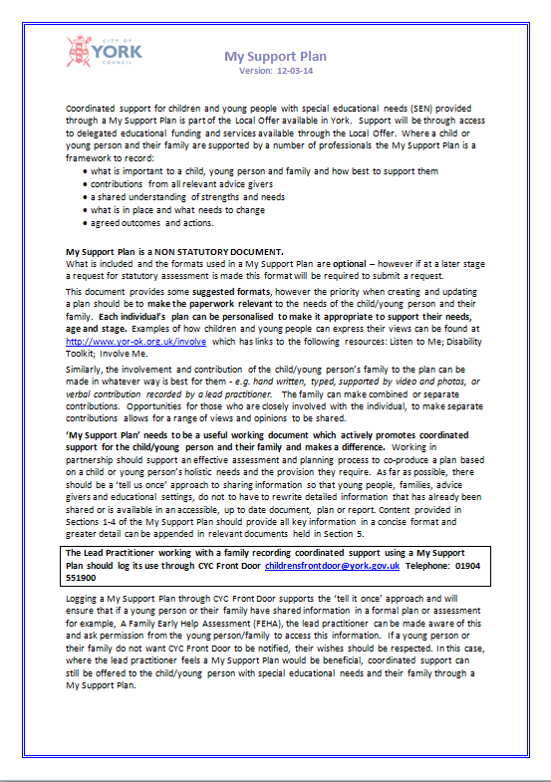
What if my child has more complex or severe needs?
At St Barnabas we strive to ensure that your child reaches their full potential. Sometimes children have complex and severe needs that may need support from other outside agencies. We may therefore ask the Local Authority for a Statutory Assessment. Under new legislation, which came into effect in September 2014, all children who have significant special needs will undergo an Education Health Care (ECH) Assessment. This may lead to an EHC Plan instead of a Statement of SEN. If their needs can be met through school support then provision will continue to be met and coordinated through a My Support Plan (MSP).
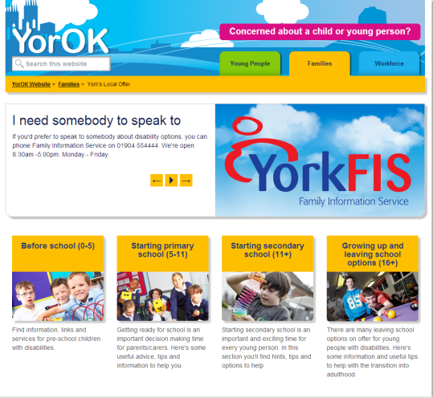
If extra support or resources are needed to help your child with their learning, above the level of support that the school can offer (for example staff time, special equipment, or attending an Enhanced Resource Provision setting) the Local Authority will provide these. This extra provision will be reviewed annually and would include input from parent, teacher, SENCo and pupil.
More details of services and support that are available through the Local Authority can be found in the Local Offer section of the YorOK website. (Click to follow link)

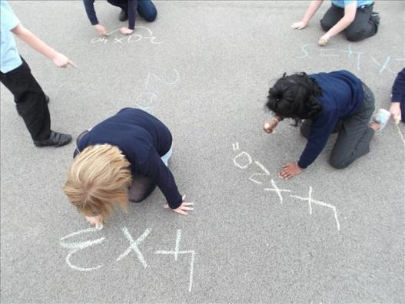
How is my child’s progress assessed and reviewed?
Teachers are continually assessing, reviewing and planning for your child’s needs. At St Barnabas we monitor and track the progress that the children are making half termly. We moderate with other teachers, both in school and with other teaching colleagues city wide, to make sure that the judgements we make are correct. Each term Miss Boardman and the Governing Body monitor the progress that children are making and the standards of teaching that they are receiving. Class teachers then hold Pupil Progress Meetings to discuss progress and any children that may need extra support.
Parents of children with SEN, are invited to meet with class teachers and /or Miss Conolly termly to discuss their child’s progress and any further support that may be required to help them with their learning.
Children with an EHC Plan have this reviewed annually.

My child is moving on to secondary school. How will their new school know about their Special Educational Needs?
Each year as children move from Year Six into their new secondary school a transition meeting is held with a member of staff from the new school. If your child has a Special Educational Need then this meeting will include the new school SENCo. Information about learning needs will be passed on in this meeting. If your child has a My Support Plan or EHC Plan this will also be passed on. We will arrange a pre visit, in addition to the Year Six transition day, to the school so the children can see what their secondary school is like and meet staff who may be involved with supporting their learning needs.
Complaints Procedure:
At St Barnabas we strive to ensure that children of all needs and abilities receive the best education that they possibly can. If you have a complaint about the provision that your child is receiving with regards to SEND please do not hesitate to contact Miss Connolly or Miss Boardman, in the ways set out below and we will try to deal with any issues. You can also write to Mrs Williamson, our SEN Governor at the school address below.
And finally…
At St Barnabas we are committed to helping your child reach their full potential. If you have any questions, queries or suggestions on how we can improve our SEN provision please do not hesitate to contact either your child’s class teacher, Miss Connolly, our school SENCo, Mrs Blows our Children’s Champion or Miss Boardman, our Headteacher. We can be contacted through school by the following ways;
Email: stbarnabas@york.gov.uk
Telephone: 01904 653323
In writing via the school office: St Barnabas CE Primary School, Jubilee Terrace, Leeman Road, York, YO26 4YZ
Or please find us at the end of the day to have a chat.
Further information can be found on these websites:
Useful websites:
Our school website: http://stbarnabasprimary.co.uk/
Information about the local offer can be found at https://www.yor-ok.org.uk/families/Local%20Offer/sendlocaloffer
Our School Ofsted report: http://reports.ofsted.gov.uk/inspection-reports/find-inspection-report/provider/ELS/121473
Our SEND Report is reviewed annually by the Full Governing Body
Report Date: 2.12.19
Review Date: December 2020

If you need a copy of this booklet we can provide a paper copy, email it to you or you can download it from the school website.

