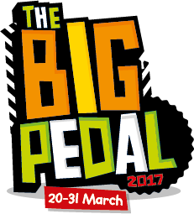
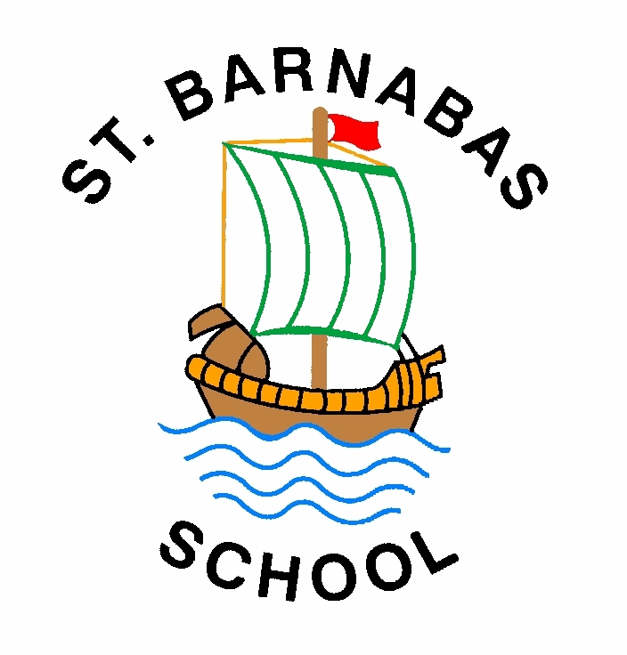

15th March 2017

Dear Parents/Carers,

Get set… we’re taking part in The Big Pedal 2017, the UK’s largest inter-school cycling and scooting challenge that inspires pupils, staff and parents to choose two wheels for their journey to school.

The challenge runs from 20th (next Monday) to 31st March. It’s free to enter and we would love everyone to be involved.

The details
On each day of the challenge schools compete to see who can record the greatest number of pupils, staff and parents cycling or scooting to school. Our best 5 days will determine our final position in the challenge. We’ll be competing against other schools locally and right across the UK, and if we clock up the most bike and scooter journeys we’ll win!

Why we’re taking part
It’s a great way to get more of our pupils travelling to school on their bikes and scooters. We will be competing to become one of the UK’s top schools for two-wheeled journeys and will be in with a chance to win prizes including bike and scooter stunt shows and fantastic cycle and scooter storage. Each day, schools with more than 15% of pupils cycling and scooting are entered into a draw for these amazing prizes.

What’s next?
All you need to do is encourage your child(ren) to cycle or scoot to school every day during the event, and join them on their way – parent and sibling journeys count too!

For more information about the event go to www.bigpedal.org.uk

Please get in touch if you have any questions.

Enjoy the ride!

Miss K Boardman
Headteacher

Success stories
Do you have an interesting story about your child cycling to school? Are they happier since discovering cycling? Has cycling changed family life? If you’re happy to share your story, get in touch the Sustrans press office: press@sustrans.org.uk.

